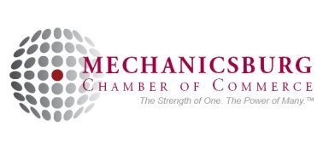
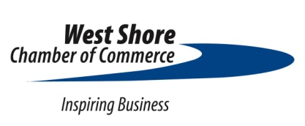

2022 Mega Mixer
Sponsorship Opportunities

The four Cumberland County Chambers of Commerce - Carlisle Area, Mechanicsburg, Shippensburg Area and West Shore Chambers of Commerce - are requesting sponsorship support for the 14th Annual Mega Mixer, which will be held on Tuesday, September 6, 2022 from 5:00 – 7:00 p.m.

This end-of-the-summer networking event has attracted over several hundred people for each of the past dozen years. The success of this event is attributed to our sponsors and event partners. Sponsorship opportunities are available to members of any of the four participating Chambers. If you would like an excellent opportunity to expand your business’ marketing exposure, please consider this investment and become a 14th Annual Mega Mixer sponsor.

$5,000 Main Sponsor Benefits (limit one): SOLD - Highmark
- Logo on Carlisle Area, Mechanicsburg, Shippensburg and West Shore Chambers of Commerce Websites
- Logo placement on each of the host’s newsletters and/or events flyer
- Banner privileges at the event
- Logo on signage at event
- Logo on event napkins
- Logo on event nametags
- Display table in a prominent location
- Opportunity for podium time at event
- Opportunity to provide give-a-ways
- Visibility to over 5,000 businesses before and through the event
- Inclusion in media releases

$2,500 Supporting Sponsor Benefits (limit two):
- Listing on Carlisle Area, Mechanicsburg, Shippensburg and West Shore Chambers of Commerce Websites
- Listing on each of the host’s newsletters and/or events flyer
- Logo on signage at event
- Display table in a prominent location
- Opportunity to provide give-a-ways
- Visibility to over 5,000 businesses before and through the event
- Inclusion in media releases

$1,000 Exhibiting Sponsor Benefits (unlimited):
- Logo on signage at event
- Display table
- Opportunity to provide give-a-ways

Please contact Jeff Palm at 717-796-0811 or email director@mechanicsburgchamber.org. Thank you!

The collaborating Chambers of Commerce agree to provide the goods and services to the undersigned as a sponsor in regards to the 2022 Mega Mixer. The sponsoring company agrees to provide payment for these goods and services by the date of the event. This agreement recognizes the minimum goods and services to be provided. However due to unforeseen circumstances, if there needs to be an adjustment to the goods or services to be provided, upon both party’s approval, goods or services to the equivalent or better will be provided.

Sponsoring Company

Sponsor Contact Title

__
Contact Address/City/State/Zip Code

__
Contact Telephone

__
Contact E-Mail

Sponsor Invoice Contact

__
Invoice Address/City/State/Zip Code

__
Invoice Telephone

__
Invoice E-Mail

